**Neck, Shoulder and Upper back pain**

**Initial Assessment**

|  |  |  |
| --- | --- | --- |
| **Presenting Symptom/Chief Complaint** | | |
| Neck pain for 5 years, aggravated by work extended to both shoulders and upper back. | | |
| **Main Signs and Symptoms** | | |
| Sudden onset and limitation of movement in turning the neck from side to side after repeated acute attacks without treatment. | | |
| **Other Signs and Symptoms** | | |
| Stiffness and rigidity due to wind-cold invasion and neck sprain. | | |
| **TCM Diagnosis and Treatment (identified TCM disease, TCM differentiation of syndromes)** | | |
| The predisposing factor liver QI stagnation with liver yang rising. | | |
| **Treatment Principles and Strategies** | | |
| Treatment principles-expel wind and treat the upper part of greater yang channels(UB) | | |
| **Treatment Plan (Modalities; acupuncture, herbal, dietary, manual therapies), frequency and duration** | | |
| Acupuncture only with local points play a primary roll by tonification method and distal points with reduction. | | |
| **Any other Advice Given to Patients** | | |
| Local points: LLB 10(bilateral)  DU 16 and GB 20 (bilateral)  Back of neck and shoulders pain due to wind  GB21-bilateral relaxation of trapezius muscle.  Distal points: LLB60 (bilateral) due to the greater yang channel. Due to chronic condition SI channel points involved. SI-II, SI-12,SI-13 (bilateral) due to tenderness on diagnosis. | | |
| **Practitioner:** | **Date:** | **Signature:** |

**Neck, shoulder and upper back pain**

**Daily Charting____________________________________Patient Name:**

**Date:**

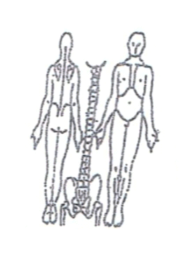 **Working Diagnosis:**

Neck upper back, shoulder pain due to chronic obstruction pain syndrome (wind, cold, dampness) with liver QI stagnation.

S: Pain 3-4 on pain scale. Sleep distortion. Radiation to upper back and shoulders.

O:

Treatment (P) Local points: LLB 10(bilateral), DU 16 and GB 20 (bilateral). GB21-bilateral relaxation of trapezius muscle. Distal points: LLB60 (bilateral) due to the greater yang channel. Due to chronic condition SI channel points involved. SI-II, SI-12,SI-13 (bilateral) due to tenderness on diagnosis

* Acupuncture due to protocol - 1 hour.

**Date: April 13, 2016 _______________**

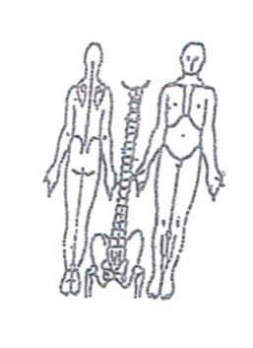**Working Diagnosis:**

S: Pain the same.

O: Sleep disturbances, low energy level.

Treatment (P) The same.

(A) Acupuncture due to protocol -1 hour.

**Date: April 15, 2016**

**Working Diagnosis:**

S: Pain 3-4 on pain scale.

O: Sleep-better. ROM-increased.

Treatment (P) Insertion of the needles with the patient movement of the neck.

(A) Acupuncture due to protocol – 1 hour.

**Date: April 18, 2016**

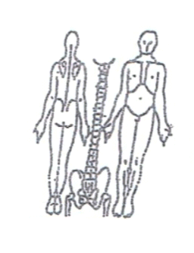**Working Diagnosis:**

S: Pain the same

O: Energy level ROM

Treatment (P) According to the treatment plan.

(A) Acupuncture due to protocol – 1 hr.

**Daily Charting____________________________________Patient Name:**

**Date: April 20, 2016 _______________**

**Working Diagnosis:**

S: Pain the same

O: Energy level ROM

Treatment (P) According to the treatment plan.

(A) Acupuncture due to protocol - 1 hr.

**Date: April 22, 2016** 

**Working Diagnosis:**

S: Pain 2-3

O: Sleep better, energy level normal, ROM the same.

Treatment (P) According to the treatment plan.

(A) Acupuncture due to protocol – 1 hr.

**Date: April 25, 2016**

**Working Diagnosis:**



S: Pain 2-3

O: ROM –normal. Energy level N. Sleep well.

ROM-increased

Treatment (P) According to the plan +Moxa.

(A) Acupuncture due to protocol – 1hr.

**Date: April 27, 2016**

**Working Diagnosis:**



S: Pain 2-3

O: ROM –normal. Energy level N. Sleep well.

ROM-increased

Treatment (P) According to the plan +Moxa.

(A) Acupuncture due to protocol – 1hr.

**Date: April 29, 2016**

**Working Diagnosis:**

S: No pain. ROM N.

O: Energy level N. Sleep N.

Treatment (P) Acupuncture, exercises, warm up diet.

(A) Acupuncture due to protocol -1 hr.